Enzyme Design and Substrate Docking Analysis

1. Objective
The objective of this project was to computationally analyze the interaction between an enzyme and a substrate using bioinformatics and molecular docking techniques. The project aimed to prepare enzyme and ligand structures, perform molecular docking, and visualize the enzyme–substrate complex to understand possible binding interactions.
This project was designed to provide a structured workflow for studying molecular interactions using computational tools, which can be useful in enzyme engineering, drug discovery, and structural biology research.

2. Tools / Technologies Used
The following tools and technologies were used in this project based on the uploaded workflow and scripts

Programming Language
- Python

Bioinformatics / Molecular Modeling Tools
- AutoDock Vina
- PyMOL
- PyMOL2
- Open Babel
- Biopython
- AlphaFold / ColabFold
- MGLTools

Python Libraries / Modules
- os
- subprocess
- requests
- pymol
- pymol2
- vina
- numpy
- matplotlib

File Formats Used
- .fasta
- .pdb
- .pdbqt
- .sdf

3. Methodology
The project followed a computational molecular docking workflow to study enzyme–substrate interaction.

Step 1: Enzyme and Substrate Preparation
The project started with identifying the enzyme and substrate files required for analysis. The enzyme sequence or structure was prepared and stored in the project data folder. Similarly, the ligand or substrate structure was also collected in a suitable molecular format.
The enzyme data was represented using sequence and structure files, while the substrate was prepared in ligand-compatible molecular format for docking analysis.

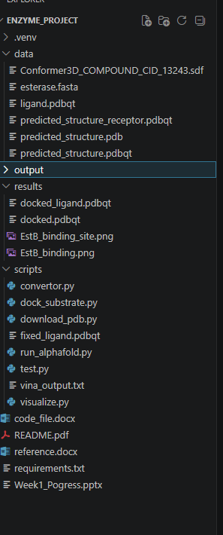
Figure 1: Input files used for enzyme and substrate preparation

Step 2: Structure Conversion
A Python script was used to convert the enzyme and ligand files into PDBQT format, which is required for docking in AutoDock Vina. During this process, molecular preparation steps such as adding hydrogens and formatting atom information were performed.
This conversion is essential because docking software requires receptor and ligand files in a standardized docking-compatible format.

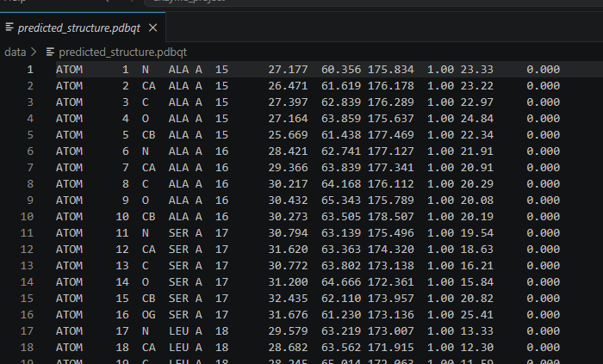

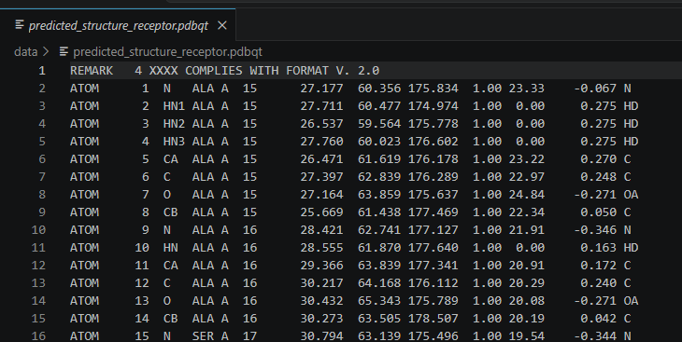
Figure 2: Conversion of enzyme and ligand structures into PDBQT format

Step 3: Molecular Docking
After preparation, molecular docking was performed using AutoDock Vina. The enzyme was treated as the receptor and the substrate as the ligand. Docking box coordinates and size parameters were defined to focus the docking process on the probable active site region of the enzyme.
The docking process generated possible binding poses for the substrate and saved the docked output file for further analysis.
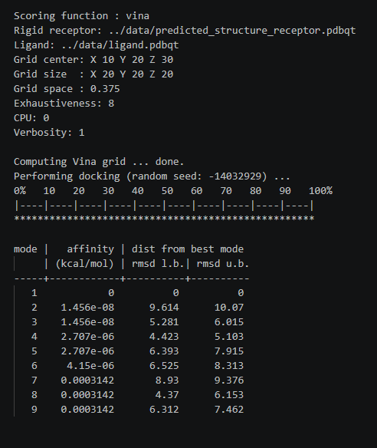
Figure 3: Molecular docking execution using AutoDock Vina

Step 4: Visualization of Docked Complex
The docked enzyme–substrate complex was visualized using PyMOL / PyMOL2. The enzyme was displayed in cartoon format and the ligand in stick format. Different colors were applied to distinguish the molecular components clearly.
The binding region near the ligand was also highlighted to understand the possible substrate interaction pocket within the enzyme structure.
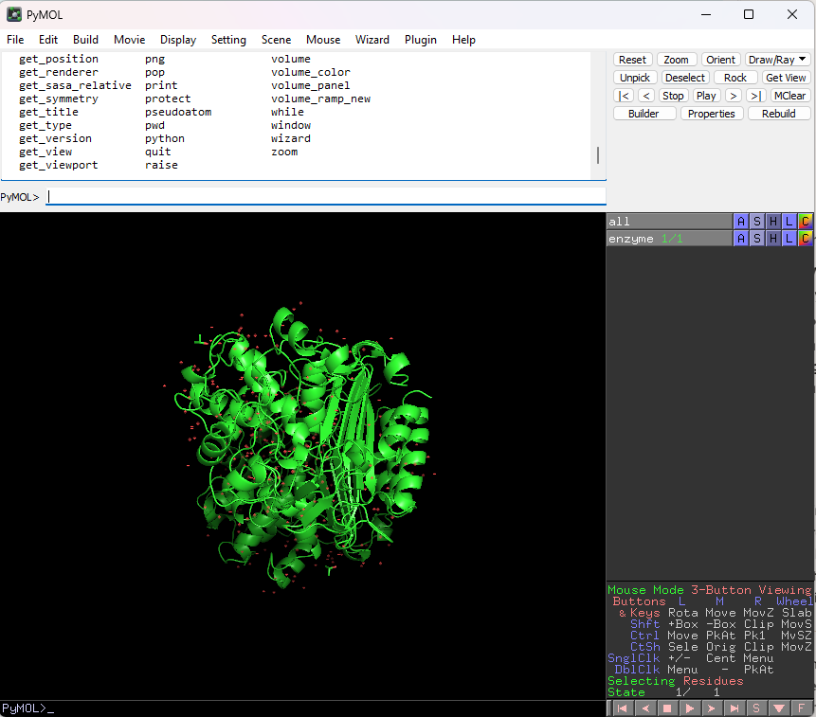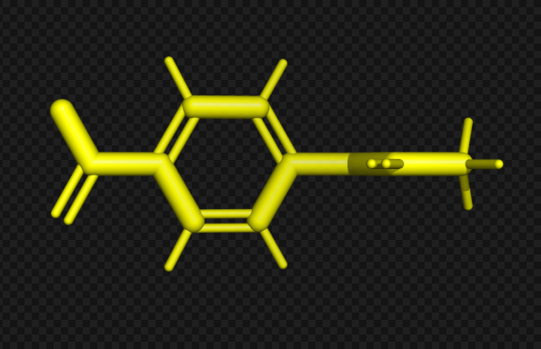
Figure 4: Visualization of docked enzyme–substrate complex in PyMOL

Step 5: Binding Pocket Identification
To better understand the interaction between the enzyme and substrate, the binding pocket region around the ligand was highlighted. This allowed identification of the nearby residues or molecular environment that may be involved in substrate binding and catalytic activity.
This step is important for interpreting the docking result and understanding how the ligand fits into the active site of the enzyme.
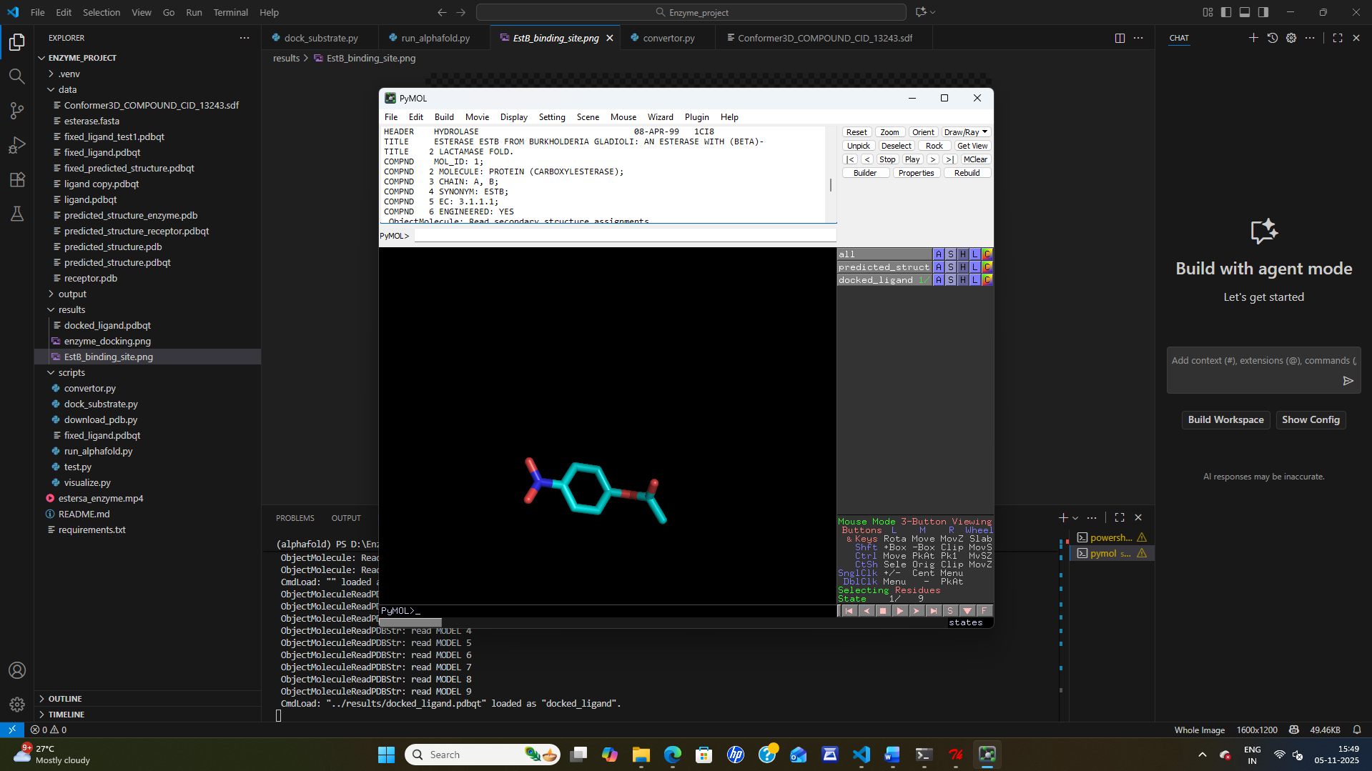Figure 5: Binding pocket and substrate interaction region

Step 6: Output Generation
The final docked structure and rendered images were generated and saved as project outputs. These outputs help in interpreting molecular binding and can be used for future structural or functional analysis.
The generated files include processed molecular structures, docking outputs, and visual representations of the docked complex.
Output File | Description
receptor.pdbqt | Prepared enzyme docking file
ligand.pdbqt | Prepared substrate docking file
docked.pdbqt | Docking result output
EstB_binding.png | Docked complex visualization
complex.png | Final rendered structure image
Table 1: Output files generated during the project

4. Outcome / Results
The project successfully established a computational workflow for studying enzyme–substrate interaction.

Key Results
- Prepared enzyme and ligand structures for computational analysis.
- Converted molecular files into docking-compatible formats.
- Performed molecular docking using AutoDock Vina.
- Generated docked binding poses of the substrate with the enzyme.
- Visualized the docked enzyme–substrate complex using PyMOL.
- Identified and highlighted the probable binding pocket region.

Project Outcome
This project demonstrated how computational biology tools can be used to predict and visualize molecular interactions efficiently. It provided practical understanding of structural bioinformatics, molecular docking, and protein–ligand visualization.
The workflow developed in this project can be further extended for:
- enzyme engineering,
- active site analysis,
- substrate specificity studies,
- and computational drug or biomolecule screening.

Final Result Interpretation
The docking and visualization outputs indicate a probable binding interaction between the enzyme and substrate. The highlighted pocket region suggests the likely active-site environment where the ligand is accommodated. The generated molecular complex can be used for further computational or experimental analysis.

Figure 6: Final docking result showing enzyme–substrate interaction

5. Conclusion
This project successfully demonstrated a computational approach for studying enzyme–substrate interaction through structure preparation, molecular docking, and visualization. It provided practical exposure to important bioinformatics tools and techniques used in structural biology and molecular modeling.
Through this project, valuable understanding was gained in file preparation, docking workflow execution, protein–ligand interaction analysis, and structural visualization. The project can serve as a foundation for future work in enzyme engineering, molecular screening, and computational biology research.

